Data lake performance

Lab 3- Create tables with multiple file formats

Estimated completion time
- 20 minutes

Learning objectives
- In this lab, you will gain experience creating tables in different file formats using the CTAS method. You will also join these tables, using a variety of techniques to build and consolidate your skills.

Prerequisites
- Student setup - Lab 1: Create student account

Activities
- Prepare for the exercise
- Create managed parquet table for orders
- Review summary information
- Create managed ORC table for line items
- Join tables
- Create managed Avro table for customer
- Verify nation table
- Modify join query to include new table
- Create managed RCText table for region
- Create managed JSON table for supplier

Step 1 - Prepare for the exercise
- Sign in and verify the students role is selected in the upper-right corner.
- Ensure the aws-us-east-1-free Cluster is reporting a Status of Running.
- In the Query editor, select aws-us-east-1-free in the cluster pulldown.

Note: If you did not previously create a schema, execute the following SQL statement. Make sure that you replace yourname with your actual name, or another identifier that you prefer. Only use lowercase characters and numbers; no special characters or spaces.

CREATE SCHEMA students.yourname;

Step 2 - Create managed parquet table for orders
In this exercise, you will create tables using a variety of supported file types and leverage them together in a multi-table join statement.

The tables that exist in tpch.sf1 schema and the logical relationships between them are listed below.

Review these relationships thoroughly. You’ll need to use these relationships to proceed further in the lab.

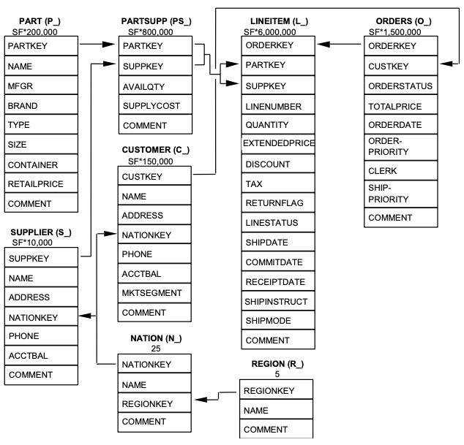

Using the CTAS statement below, create a managed table in your own schema that contains the contents of tpch.sf1.orders. Use the Parquet file format for this new table.

USE students.yourname;

CREATE TABLE
t_orders_parquet
WITH
(format = 'Parquet') AS
SELECT
*
FROM
tpch.sf1.orders;

Verify that the table was properly created.

SELECT
*
FROM
t_orders_parquet
LIMIT
25;

Step 3 - Review summary information
It is considered best practice to review the S3 bucket where your data is stored to gain summary information about the newly created files.
Use the SQL query below to generate the summary.

SELECT format_number(AVG("$file_size")) AS avg_file_size,
COUNT() AS tot_nbr_files,
format_number(SUM("$file_size")) AS tot_file_size
FROM
(SELECT DISTINCT "$path", "$file_size"
FROM t_orders_parquet);

Step 4 - Create managed ORC table for line items
Using a CTAS statement, create a managed table in your own schema that contains the contents of tpch.sf1.lineitem. Use the ORC file format for this new table.

CREATE TABLE
t_lineitem_orc
WITH
(format = 'ORC') AS
SELECT
*
FROM
tpch.sf1.lineitem;

Verify that the table was properly created.

SELECT
*
FROM
t_lineitem_orc
LIMIT
25;

Run a query to determine some summary information about the newly created files.

SELECT format_number(AVG("$file_size")) AS avg_file_size,
COUNT() AS tot_nbr_files,
format_number(SUM("$file_size")) AS tot_file_size
FROM
(SELECT DISTINCT "$path", "$file_size"
FROM t_lineitem_orc);

Step 5 - Join tables
Investigate these two new tables to determine which columns should be used to join them.

Run the query below.

SELECT
o.orderkey,
l.linenumber
FROM
t_lineitem_orc AS l
JOIN t_orders_parquet AS o ON l.orderkey = o.orderkey
WHERE
l.orderkey = 1935460;

Step 6 - Create managed Avro table for customer
Using a CTAS statement, create a managed table in your schema that contains the contents of tpch.sf1.customer. Use format = 'Avro' for this new table.

CREATE TABLE
t_customer_avro
WITH
(format = 'Avro') AS
SELECT
*
FROM
tpch.sf1.customer;

Verify that the table was created properly and then determine some summary information about the newly created files using the procedure described in Step 3.

Enhance the join query to include this new table and include its name column in the results.

SELECT
o.orderkey,
l.linenumber,
c.name AS customer_name
FROM
t_lineitem_orc AS l
JOIN t_orders_parquet AS o ON l.orderkey = o.orderkey
JOIN t_customer_avro AS c ON o.custkey = c.custkey
WHERE
l.orderkey = 1935460;

The result should look similar to the image below.

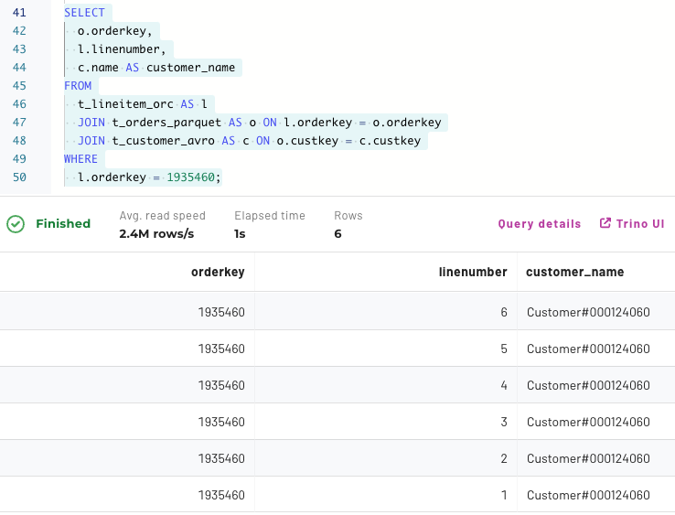

Step 7 - Verify nation table
You should already have a nation table from an earlier lab. If not, create a copy of tpch.sf1.nation with a CTAS statement using the default file format. You should leave out the format property.

Step 8 - Modify join query to include new table
Enhance the join query earlier in this lab to include the newly created table. Make sure to reference the name column in the results.

Your query should be similar to the one below.

SELECT
o.orderkey,
l.linenumber,
c.name AS customer_name,
n.name AS nation_name
FROM
t_lineitem_orc AS l
JOIN t_orders_parquet AS o ON l.orderkey = o.orderkey
JOIN t_customer_avro AS c ON o.custkey = c.custkey
JOIN nation AS n ON c.nationkey = n.nationkey
WHERE
l.orderkey = 1935460;

Step 9 - Create more tables with additional file formats
Run the following three CTAS statements utilizing some of the additional supported file formats.

Note: These file formats are not recommended for new efforts, but are supported for legacy systems that leverage some, or all, of them.

CREATE TABLE t_region_rctext
WITH (format = 'RCText') AS
SELECT * FROM tpch.sf1.region;

CREATE TABLE t_part_sf
WITH (format = 'SequenceFile') AS
SELECT * FROM tpch.sf1.part;

CREATE TABLE t_supplier_json
WITH (format = 'JSON') AS
SELECT * FROM tpch.sf1.supplier;

Step 10 - Join 7 tables of differing file formats
Finally, join all of the new tables created in this exercise.

SELECT
O.orderkey, l.linenumber,
c.name AS customer_name,
n.name AS nation_name,
r.name AS region_name,
p.name AS part_name,
s.name AS supplier_name
FROM
t_lineitem_orc AS l
JOIN t_orders_parquet AS o ON l.orderkey = o.orderkey
JOIN t_customer_avro AS c ON o.custkey = c.custkey
JOIN nation AS n ON c.nationkey = n.nationkey
JOIN t_region_rctext AS r ON n.regionkey = r.regionkey
JOIN t_part_sf AS p ON l.partkey = p.partkey
JOIN t_supplier_json AS s ON l.suppkey = s.suppkey
WHERE
l.orderkey = 1935460;

The solution above was useful to determine all the joins. A more analytical view of the data may require calculating how many line items exist for each supplier/brand name combination for each customer region. That could yield a modified aggregation query such as the following.

SELECT
s.name AS supplier_name, p.brand AS brand_name,
r.name AS region_name, --customer region, not supplier
COUNT() AS nbr_line_items
FROM
t_lineitem_orc AS l
JOIN t_orders_parquet AS o ON l.orderkey = o.orderkey
JOIN t_customer_avro AS c ON o.custkey = c.custkey
JOIN nation AS n ON c.nationkey = n.nationkey
JOIN t_region_rctext AS r ON n.regionkey = r.regionkey
JOIN t_part_sf AS p ON l.partkey = p.partkey
JOIN t_supplier_json AS s ON l.suppkey = s.suppkey
GROUP BY
ROLLUP (s.name, p.brand, r.name)
ORDER BY
S.name, p.brand, r.name;

END OF LAB EXERCISE

